PROJECT DOCUMENTATION ON
SMART LEAD MANAGEMENT SYSTEM USING SALESFORCE

ABSTRACT
The Smart Lead Management System using Salesforce CRM is designed to automate and streamline the process of capturing, evaluating, and managing potential business leads. Traditional lead tracking methods often rely on manual data entry and inconsistent follow-ups, resulting in lost opportunities and reduced sales efficiency. To address these challenges, this project leverages Salesforce’s declarative and programmatic tools to build a dynamic, end-to-end lead management solution.
The system integrates a Web-to-Lead form for real-time lead capture, supported by custom fields such as Lead Score and Product Interest to quantify lead quality. A Record-Triggered Flow automatically evaluates each new lead, classifies high-value prospects as “Hot Leads,” and triggers personalized email alerts to the sales team. Additionally, leads are organized through Queues for team-based ownership, while Reports and Dashboards provide instant visibility into lead performance, conversion rates, and source effectiveness.
The project demonstrates how Salesforce automation enhances customer acquisition efficiency, reduces manual workload, and improves decision-making through data-driven insights. The final outcome is a scalable, intelligent lead management platform suitable for organizations aiming to optimize their sales operations with minimal human intervention.

SUBMITTED BY:
Vinay Singu
Student at
(Vignana Bharathi Institute of Technology, Hyderabad,Telanagana)

Phase 1: Problem Understanding & Industry Analysis
This phase sets the foundation for your Smart Lead Management System project.
The goal is to analyze the sales and marketing industry, identify core challenges in lead handling, and define how Salesforce CRM can automate and improve the lead management process.

🔹 1. Requirement Gathering
What it means:
Requirement gathering involves collecting and analyzing the needs of sales teams, managers, and marketing stakeholders.
It defines what the CRM system must achieve to improve lead generation, tracking, and conversion.
How to do it:
- Interview marketing and sales representatives to identify pain points.
- Review existing spreadsheets or manual systems used for lead tracking.
- Observe lead response times and follow-up delays.
Key Questions to Ask:
- How are leads currently stored and followed up?
- How are hot or high-value leads identified?
- What metrics do managers want to track (e.g., conversions, sources)?
- How quickly are leads assigned and responded to?
Example Requirements for Smart Lead CRM:
- Automatically capture leads from different channels (website, phone, email).
- Assign leads based on source, region, or score.
- Send automatic email notifications for high-priority leads.
- Provide dashboards for conversion tracking and lead source analysis.
Deliverable:
A Requirement Specification Document listing:
- Core features (lead scoring, email alerts, dashboards)
- Future scope (AI-based lead prediction, WhatsApp integration)

🔹 2. Stakeholder Analysis
What it means:
Identifying all individuals or teams affected by the CRM system and their expectations.
Stakeholder Categories:
Stakeholder | Role | Expectation
Sales Agents | Handle and follow up on leads. | Easy access to lead info, automated lead assignment.
Sales Managers | Monitor lead conversion and performance. | Reports, dashboards, and real-time updates.
Marketing Team | Generate leads via campaigns. | Track campaign success and ROI.
System Admin | Manage CRM setup and automation. | Customization and maintenance control.
Top Management | Oversee overall business growth. | High-level analytics and decision insights.
Deliverable:
A Stakeholder Map showing roles, responsibilities, and expectations.

🔹 3. Business Process Mapping
What it means:
Compare the current (manual) process with the improved (CRM-automated) one.
AS-IS Process (Manual):
- Leads collected manually from website or calls.
- Data entered in Excel sheets.
- No scoring or prioritization.
- Delayed responses → low conversions.
TO-BE Process (Smart CRM in Salesforce):
- Leads submitted via Web-to-Lead form.
- Salesforce automatically scores the lead.
- Hot leads trigger email alerts.
- Agents update status → Managers view live dashboards.
Deliverable:
Business Process Diagrams:
- AS-IS Model (manual tracking)
- TO-BE Model (automated Smart Lead CRM flow)

🔹 4. Industry-Specific Use Case Analysis
Industry: Sales & Marketing
Challenges:
- Poor lead tracking and prioritization.
- Manual assignment causes delays.
- Lack of performance insights.
CRM Use Cases:
- Auto-lead capture and scoring from web forms.
- Notification to agents for hot leads.
- Dashboard to track top-performing campaigns.
- Lead conversion tracking from contact to opportunity.
Deliverable:
An Industry Use Case Document showing how Salesforce automation improves sales workflow.

🔹 5. AppExchange Exploration
What it means:
Explore Salesforce AppExchange for ready-made lead management apps to study features and compare.
How to explore:
- Visit https://appexchange.salesforce.com/
- Search for “Lead Management”, “Sales Automation”, or “Lead Scoring”.
- Compare top apps like:
  - Salesforce Sales Cloud Lead Management
  - Einstein Lead Scoring
  - Lead Assignment and Distribution Tool

Phase 2: Org Setup & Configuration
This phase focuses on setting up the Salesforce Developer Environment, configuring user roles, permissions, and customizing the app foundation for the Smart Lead Management System.
It ensures that the CRM environment is properly structured for automation, data entry, and reporting.

🔹 1. Developer Org Setup
Objective:
To create and configure a Salesforce Developer Edition environment that supports all CRM components (Objects, Flows, Reports, Dashboards, and Apex Triggers).
Steps Followed:
- Navigated to https://developer.salesforce.com/signup
- Created a new Developer Edition Org using personal email ID.
- Verified account through confirmation email.
- Logged in to Salesforce using credentials.
- Configured profile picture, company name, time zone, and currency settings.
- Verified that essential features such as Setup, Object Manager, and App Launcher are accessible.
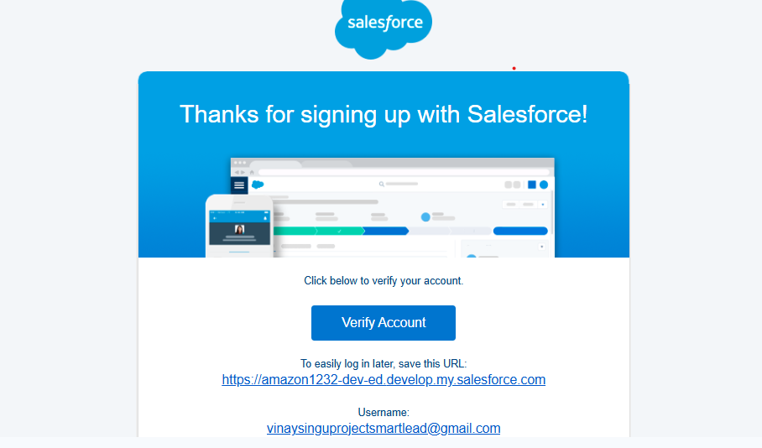
Deliverable:
A fully functional Salesforce Developer Org with administrator access, ready for customization.

🔹 2. App Creation (Lightning App Builder)
Objective:
To build a dedicated Smart Lead Management App within Salesforce for all lead operations.
Steps Followed:
- In Salesforce Setup → App Manager → New Lightning App.
- Entered:
  - App Name: Smart Lead Management
  - Developer Name: Smart_Lead_Management
  - Description: A Salesforce-based CRM app to automate and track leads.
- Added Navigation Tabs:
  - Leads
  - Accounts
  - Contacts
  - Reports
  - Dashboards
- Selected Standard Navigation (Lightning Experience).
- Added App Icon and assigned to System Administrator profile.
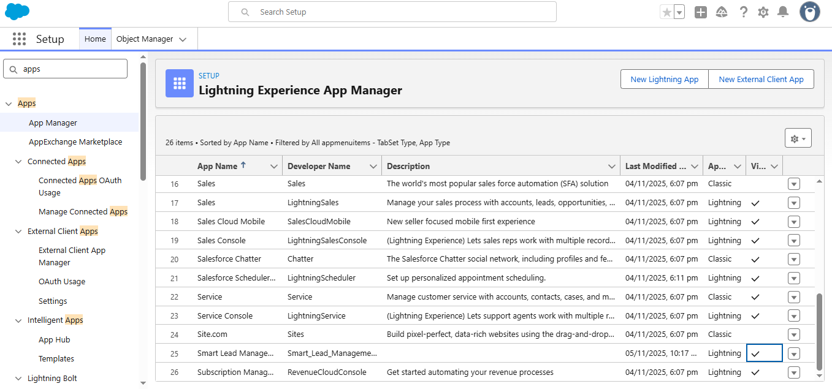
Deliverable:
Custom Salesforce App: Smart Lead Management (accessible via App Launcher)

🔹 3. User & Profile Configuration
Objective:
To define user roles and assign permissions for lead management tasks.
User Roles Created:
Role | Description | Access Level
Sales Admin | Maintains setup, flows, reports. | Full Access
Sales Manager | Monitors dashboard, lead stats. | Read/Write
Sales Agent | Works with assigned leads. | Read/Write (Own Records)
Marketing User | Adds new leads via web form. | Create/Read
Steps Followed:
- Setup → Users → Roles → Set Up Roles
- Created role hierarchy:
  - Sales Admin
    - Sales Manager
      - Sales Agent
- Assigned users (self and sample team) to roles.
- Verified data visibility with Role Hierarchy Sharing.
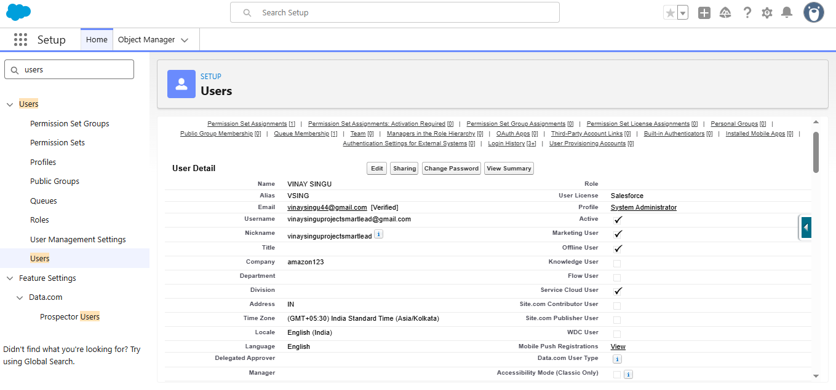

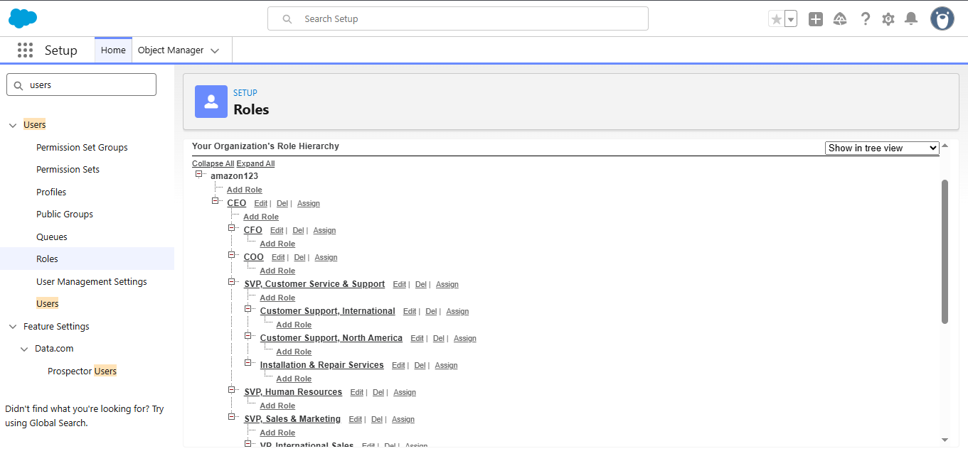
Deliverable:
Defined role hierarchy and permission matrix for Smart Lead Management.

🔹 4. Object Configuration
Objective:
To customize the Lead Object with additional fields required for automation and reporting.
Custom Fields Added:
Field Label | Type | API Name | Description
Lead Score | Number (3,0) | Lead_Score__c | Represents the potential or importance of a lead (0–100).
Source Detail | Text(255) | Source_Detail__c | Additional notes about how the lead was generated.
Product Interest | Picklist | Product_Interest__c | Products the customer is interested in (Laptop, Mobile, Software, etc.)
Steps Followed:
- Setup → Object Manager → Lead → Fields & Relationships → New.
- Added and configured all fields above.
- Added fields to the Lead Page Layout.
- Marked Lead Score as visible to all profiles.
- Verified through record creation.
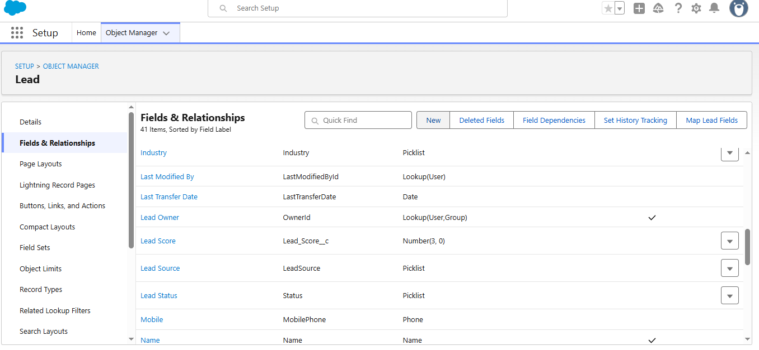Deliverable:
Enhanced Lead Object with additional data-capture and scoring capabilities.

🔹 5. Page Layout Customization
Objective:
To make data entry simple and well-structured for users.
Steps Followed:
- Setup → Object Manager → Lead → Page Layouts → Lead Layout.
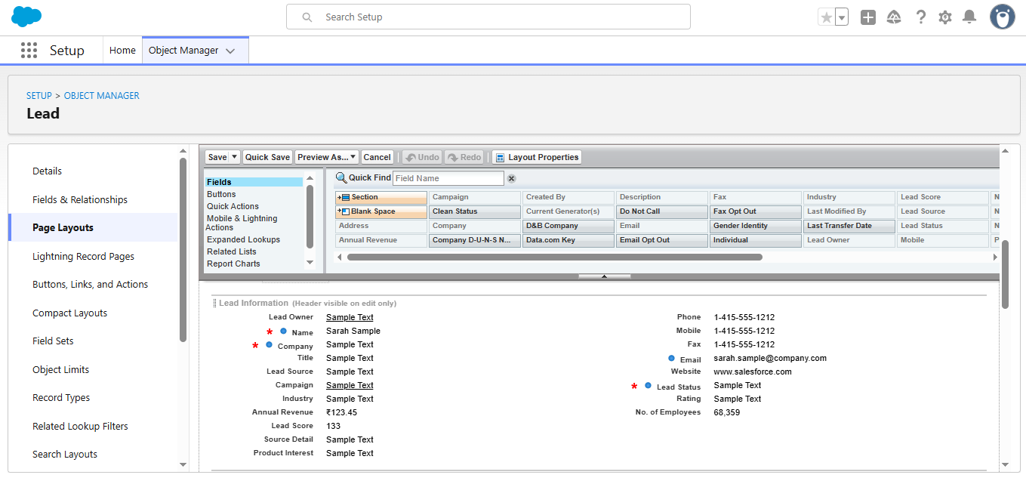
- Reorganized field sections:
  - Lead Information
  - Product Details
  - Scoring & Source Info
- Added custom fields under “Lead Details.”
- Enabled “Activity Timeline” and “Related Lists” for easier navigation.
- Saved and assigned layout to all user profiles.
Deliverable:
Custom Lead Page Layout designed for efficient data entry and clarity.

🔹 6. Validation & Testing
Objective:
To verify that configuration and setup work as expected.
Test Performed:
- Created 3 sample leads manually.
- Checked visibility for each profile.
- Confirmed that new fields appear correctly and data is saved.
- Verified the app layout under “Smart Lead Management.”
Result:
Configuration works successfully with no field or layout issues.

Phase 3: Data Modeling & Relationships
This phase focuses on defining the data model for the Smart Lead Management System.
It involves identifying key objects, establishing relationships, and ensuring that data flows logically across different entities (Leads, Accounts, Contacts, Opportunities).
The goal is to create a scalable CRM structure that supports automation, reporting, and integrations.

🔹 1. Objective
To design a structured data model in Salesforce that accurately represents the lead management process — from lead capture to conversion — and connects related objects for smooth data flow.

🔹 2. Objects Used in the System
Object Name | Type | Purpose / Description
Lead | Standard | Stores information about potential customers before qualification.
Account | Standard | Represents organizations or companies once a lead is converted.
Contact | Standard | Stores individual contact information after conversion.
Opportunity | Standard | Tracks potential deals or sales opportunities with Accounts.
Lead Queue | Custom (System Feature) | Used to assign and group leads among team members.

🔹 3. Custom Fields Added to Lead Object
Field Label | Data Type | Purpose
Lead Score | Number | Used to score the lead (0–100) based on interest and source.
Source Detail | Text | Describes where the lead originated (e.g., Google Ads, Event, Referral).
Product Interest | Picklist | Captures the type of product the lead is interested in (Laptop, Software, etc.).

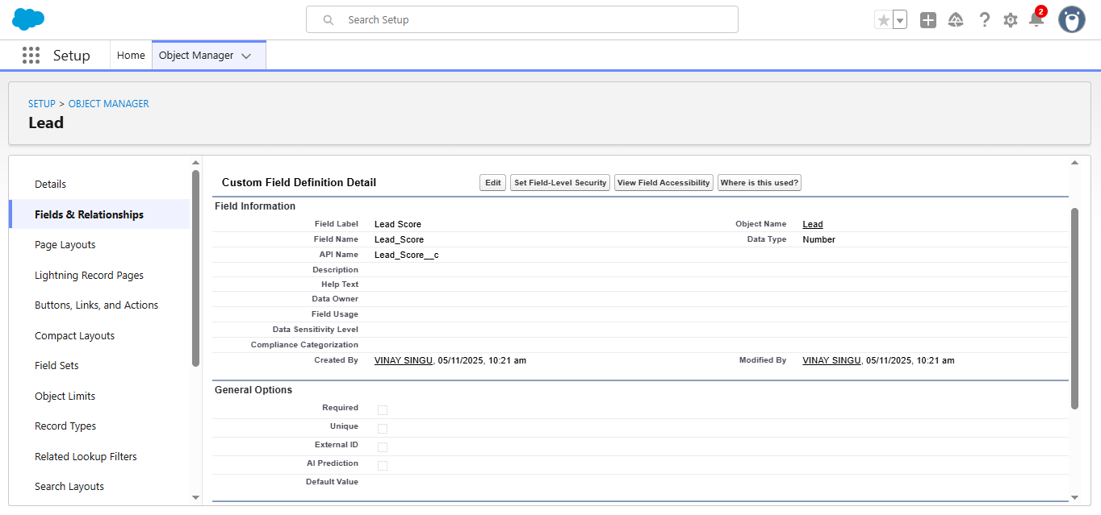

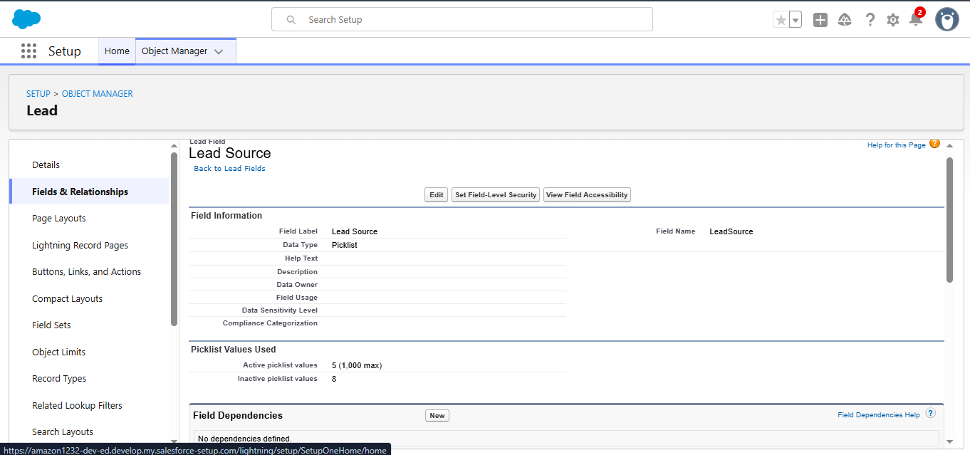

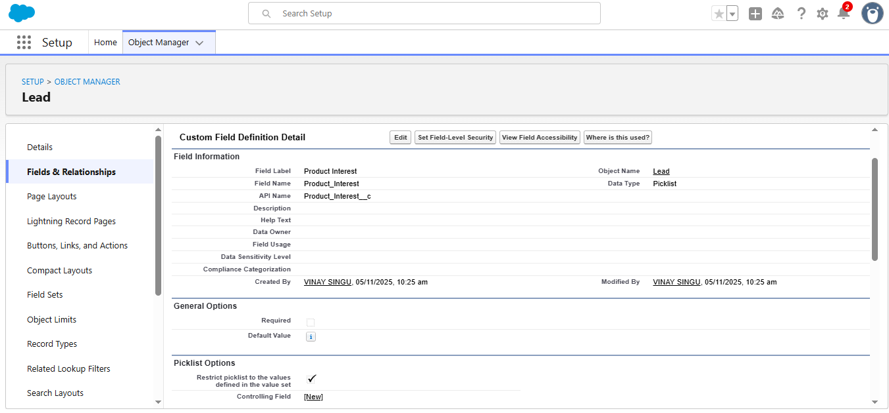

🔹 4. Relationship Mapping
Salesforce provides built-in relationships between its standard objects.
In the Smart Lead Management System, relationships ensure smooth conversion and data flow.

Key Relationships:
- Lead → Account → Contact
  - When a Lead is converted, Salesforce automatically creates:
    - A new Account (Company/Organization)
    - A new Contact (Individual Person)
  - These two are linked automatically.
- Account → Opportunity
  - Once a lead is qualified, opportunities are tracked under Accounts.
  - This helps analyze sales conversion and revenue potential.
- Lead → Queue
  - The Lead Queue helps auto-assign incoming leads to team members.
  - Assignment rules use Lead Source or Region as criteria.

🔹 5. Field-Level Security & Visibility
Objective:
To ensure data integrity and proper access control.
Steps Followed:
- Setup → Object Manager → Lead → Fields & Relationships.
- For each custom field, clicked “Set Field-Level Security.”
- Made fields Visible to all profiles (Admin, Manager, Agent).
- Set Read-Only permission for Marketing Users (for Lead Score).
Result:
All users can view and update leads according to their role hierarchy.

🔹 6. Sample Data Design
Example Lead Record:
Field | Value Example
First Name | Ravi
Last Name | Kumar
Company | TCS Pvt. Ltd.
Email | ravi.kumar@tcs.com
Lead Source | Web
Lead Score | 85
Product Interest | Laptop
Status | Hot Lead
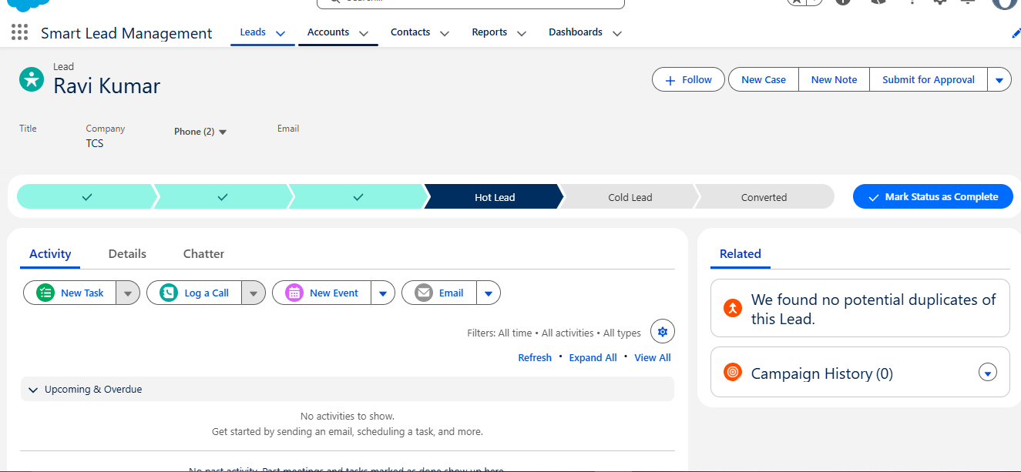
When Converted:
- Account: TCS Pvt. Ltd.
- Contact: Ravi Kumar
- Opportunity: “Laptop Purchase - TCS Pvt. Ltd.”

🔹 7. ER Diagram (Entity Relationship Diagram)
+-------------+ +-------------+ +-------------+
| Lead | ----> | Account | ----> | Opportunity |
+-------------+ +-------------+ +-------------+
│
↓
+-------------+
| Contact |
+-------------+
This relationship ensures that once a lead is qualified, it seamlessly flows into Account, Contact, and Opportunity stages.

🔹 8. Testing the Data Model
Test Case:
- Created 3 leads manually with different Lead Sources and Scores.
- Converted each lead → verified that Accounts, Contacts, and Opportunities were automatically created.
- Checked the linkages between related objects.
Result:
The data model functions correctly, ensuring smooth conversion and relationship flow.

Phase 4: Process Automation (Admin)
This phase focuses on automating lead management operations in Salesforce using Flows, Email Alerts, and Queues.
Automation eliminates manual work, ensures timely notifications, and improves the overall efficiency of the lead-handling process.

🔹 1. Objective
To automate the lead qualification, assignment, and notification process using Salesforce declarative tools such as Record-Triggered Flows, Email Alerts, and Queues — without any code dependency.

🔹 2. Tools Used
Tool | Purpose
Record-Triggered Flow | Automatically checks lead score and updates status or triggers actions.
Email Alert | Sends instant notification to sales managers for hot leads.
Queue | Automatically assigns ownership of new leads to a specific group (Sales Team).

🔹 3. Lead Queue Setup
Objective:
To assign newly created leads to a shared queue for faster access and management by the sales team.
Steps Followed:
- Setup → Queues → New.
- Entered details:
  - Label: Lead Queue
  - Queue Name: Lead_Queue
  - Object: Lead
- Added members (Sales Agents, Managers, and Admin).
- Saved the queue and verified ownership assignment.
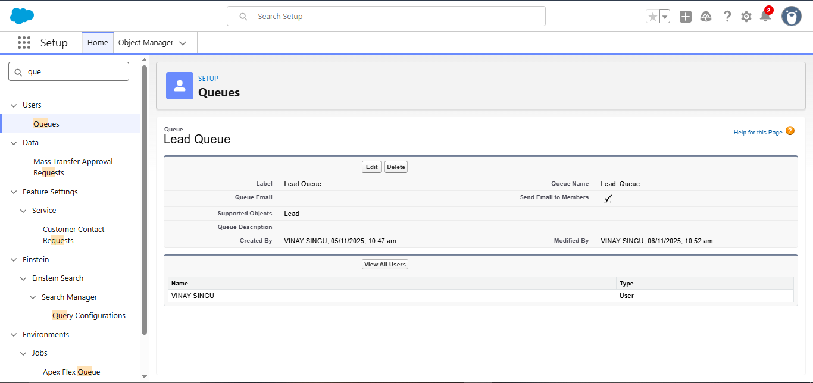
Deliverable:
Lead Queue created and assigned to the Sales team.

🔹 4. Email Template Creation
Objective:
To send a professional email notification when a “Hot Lead” (Lead Score ≥ 70) is created.
Steps Followed:
- Setup → Classic Email Templates → New Template.
- Selected Text / HTML (using Letterhead).
- Entered details:
  - Folder: Unfiled Public Email Templates
  - Template Name: Hot Lead Alert
  - Subject: 💼 New Hot Lead Alert- {!Lead.Name}
HTML VERSION:
Hello Team,
A new <strong>HOT LEAD</strong> has just been captured!
<b>Lead Details:</b><br>
• <b>Name:</b> {!Lead.FirstName} {!Lead.LastName}<br>
• <b>Company:</b> {!Lead.Company}<br>
• <b>Lead Score:</b> {!Lead.Lead_Score__c}<br>
• <b>Source:</b> {!Lead.LeadSource}<br>
• <b>Product Interest:</b> {!Lead.Product_Interest__c}<br><br>
Please follow up immediately in Salesforce using the Smart Lead Management App.<br><br>
Thank you,<br>
<b>Smart Lead Management System</b><br>
<small>This is an automated message — do not reply.</small>
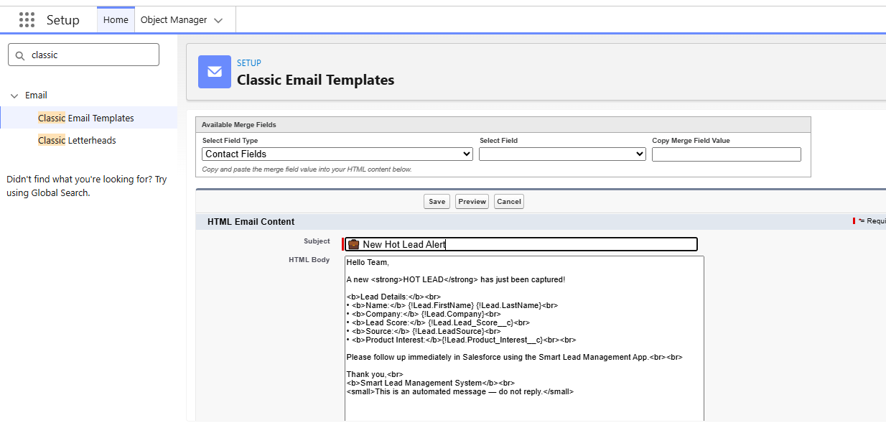
Deliverable:
Email template Hot Lead Alert ready for automation use.

🔹 5. Email Alert Configuration
Objective:
To trigger the email notification when a new high-scoring lead is created.
Steps Followed:
- Setup → Email Alerts → New Email Alert.
- Entered:
  - Description: Send notification when a Hot Lead is created.
  - Object: Lead
  - Email Template: Hot Lead Alert
  - Recipients: Sales Managers & Admin
- Saved and activated alert.
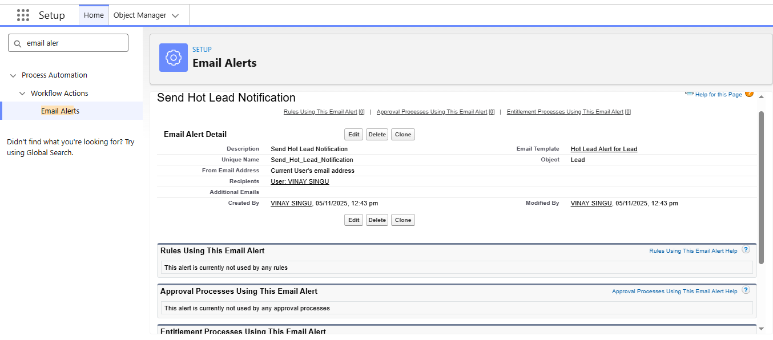
Deliverable:
Email Alert Send Hot Lead Notification configured successfully.

🔹 6. Flow Creation (Record-Triggered Flow)
Objective:
To automatically check the lead score upon creation and perform actions (assign queue, send email, or update status).
Steps Followed:
- Setup → Flows → New Flow → Record-Triggered Flow.
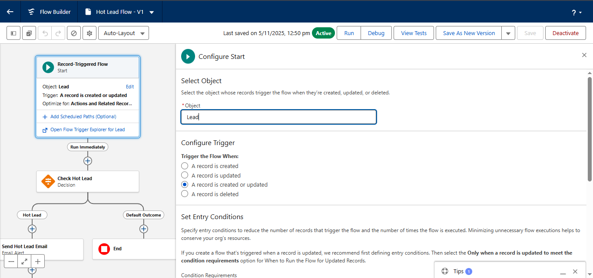
- Object: Lead
- Trigger: When a record is created.
- Added Decision Element: “Check Hot Lead”
  - Condition: {!$Record.Lead_Score__c} ≥ 70
  - Outcome: Hot Lead
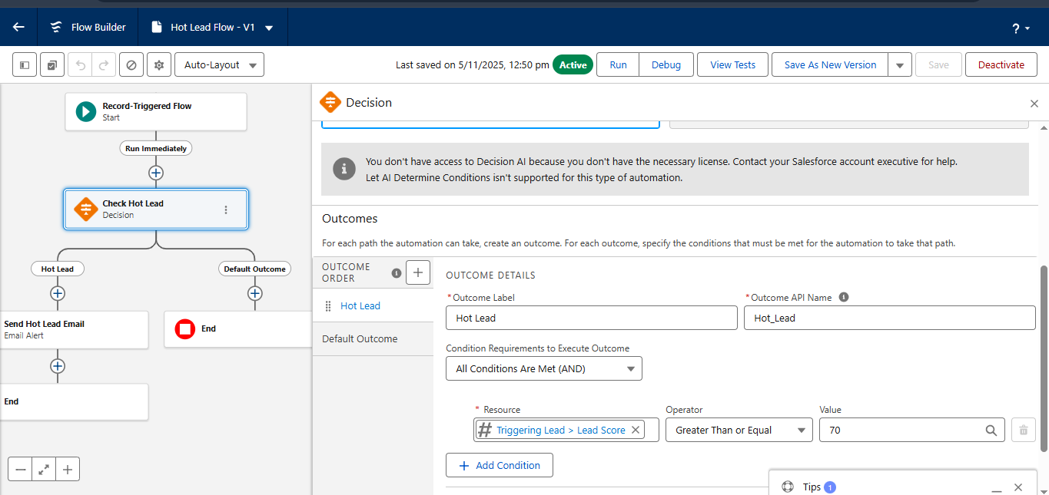
- Added Actions:
  - Update Field → Lead Status = Hot Lead
  - Assign Lead Owner → Lead Queue
  - Trigger Email Alert → Send Hot Lead Notification
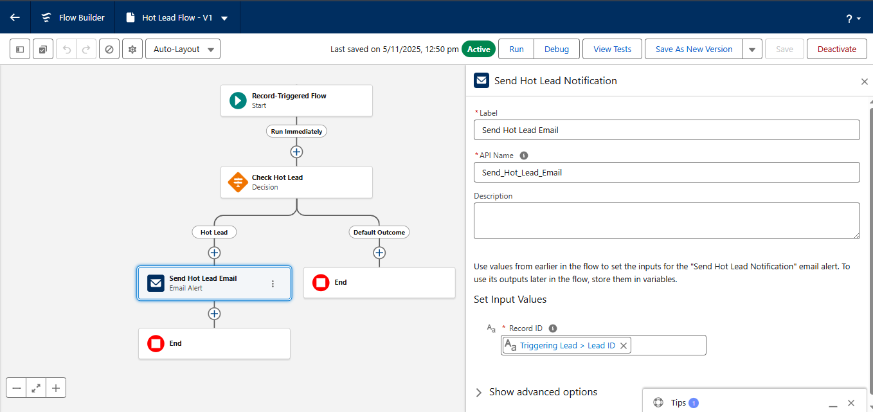
- Added Default Outcome: Cold Lead → Status = Cold Lead.
- Saved flow as Hot_Lead_Flow → Activated.
Deliverable:
Flow Hot Lead Flow created and activated for automatic lead handling.

🔹 7. Testing the Automation
Test Case 1:
- Created new lead with Lead Score = 85.
Result:
Lead automatically assigned to Lead Queue.
Status updated to Hot Lead.
Email alert received by Sales Manager.
Test Case 2:
- Created new lead with Lead Score = 40.
Result:
Status updated to Cold Lead.
No email triggered.
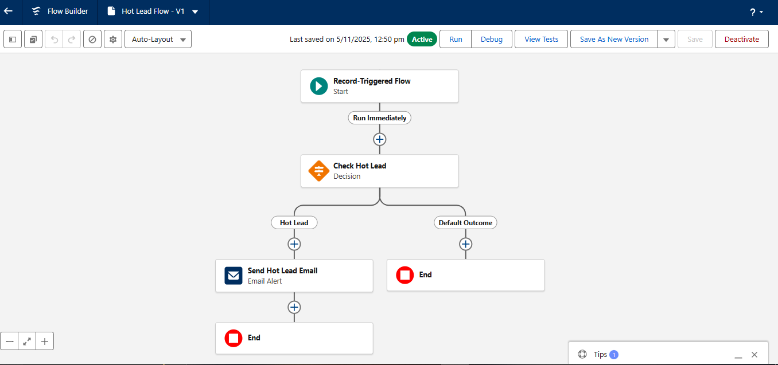
Outcome:
Automation logic working correctly

🔹 8. Benefits of Process Automation
- Saves manual effort in assigning and tracking leads.
- Ensures fast response time for high-priority leads.
- Reduces human error in lead categorization.
- Enhances coordination between marketing and sales teams.

Phase 5: Apex Programming (Developer)
This phase focuses on implementing programmatic automation using Apex Triggers and Test Classes.
While admin tools like Flows handle most automation, Apex provides more control, complex logic handling, and scalability.
The goal of this phase is to create a Lead Assignment Trigger that automatically assigns leads based on Lead Score and to validate it through a Test Class.

🔹 1. Objective
To implement server-side logic using Salesforce Apex for dynamic lead management.
This ensures that high-priority leads are automatically assigned to the sales queue, and validation is performed through test coverage.

🔹 2. Apex Trigger Overview
Purpose:
The trigger executes whenever a Lead record is inserted or updated.
It checks the Lead Score and automatically assigns it to the Lead Queue if the score meets the “Hot Lead” criteria.

🔹 3. Apex Trigger Code: LeadAssignmentTrigger.trigger

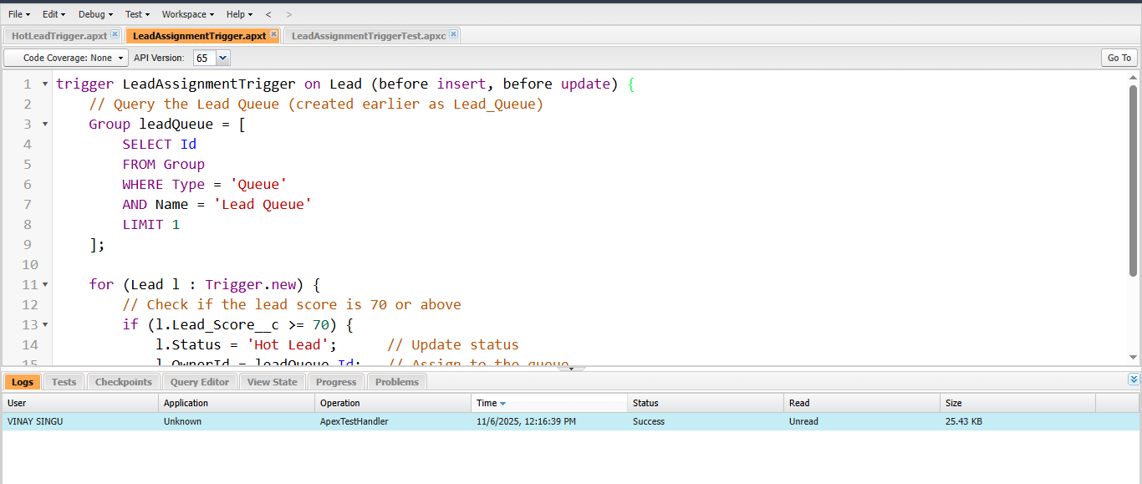
trigger LeadAssignmentTrigger on Lead (before insert, before update) {

// Step 1: Get the Lead Queue Id (Named "Lead Queue")
Group leadQueue = [SELECT Id FROM Group WHERE Name = 'Lead Queue' AND Type = 'Queue' LIMIT 1];

for (Lead l : Trigger.new) {
// Step 2: Check if Lead Score is available
if (l.Lead_Score__c != null) {

// Step 3: If Lead Score ≥ 70, mark as Hot and assign to queue
if (l.Lead_Score__c >= 70) {
l.Status = 'Hot Lead';
l.OwnerId = leadQueue.Id;
}
// Step 4: Otherwise, mark as Cold Lead
else {
l.Status = 'Cold Lead';
}
}
}
}

🔹 4. Code Explanation
Step | Logic | Purpose
Step 1 | Fetches the ID of the “Lead Queue”. | Allows assigning hot leads directly to the queue.
Step 2 | Checks if the Lead Score field is not null. | Ensures that only scored leads are processed.
Step 3 | If Lead Score ≥ 70 → sets Status = “Hot Lead” and assigns owner to queue. | Automates assignment of high-priority leads.
Step 4 | Else sets Status = “Cold Lead”. | Categorizes low-priority leads automatically.

🔹 5. Apex Test Class: LeadAssignmentTriggerTest.cls
Purpose:
To test and validate the trigger logic, ensuring 100% test coverage and correct functionality during deployment.
@isTest
public class LeadAssignmentTriggerTest {

@isTest
static void testLeadAssignment() {

// Step 1: Get the Lead Queue ID
Group leadQueue = [SELECT Id FROM Group WHERE Name = 'Lead Queue' AND Type = 'Queue' LIMIT 1];

// Step 2: Create a sample Hot Lead
Lead hotLead = new Lead(
FirstName = 'Ravi',
LastName = 'Kumar',
Company = 'TCS Pvt. Ltd.',
Lead_Score__c = 85,
Status = 'New'
);
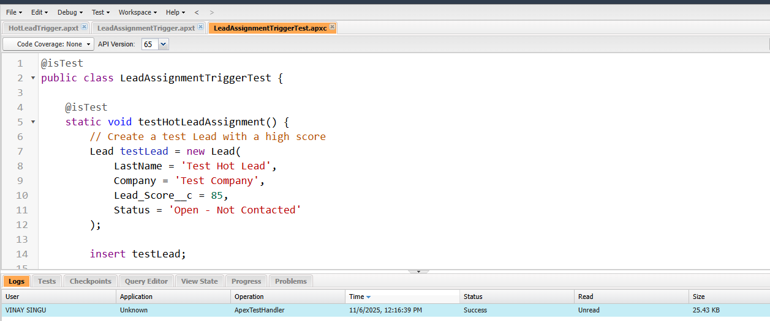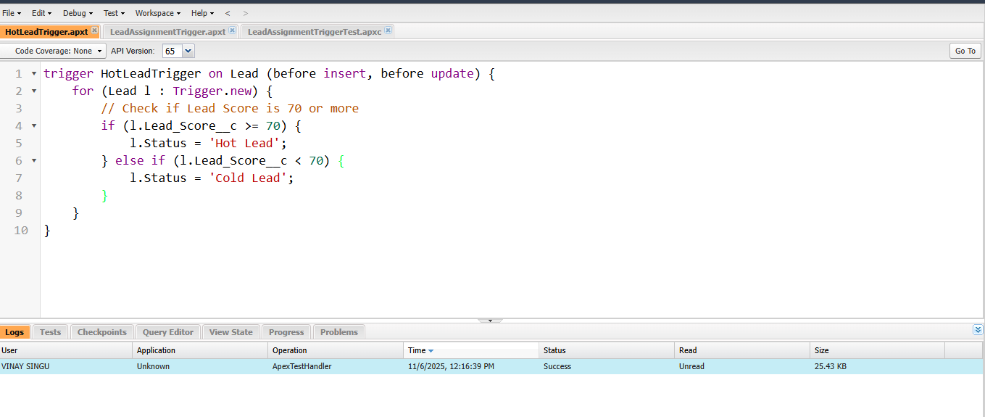
// Step 3: Create a sample Cold Lead
Lead coldLead = new Lead(
FirstName = 'Anjali',
LastName = 'Sharma',
Company = 'Infosys',
Lead_Score__c = 45,
Status = 'New'
);

// Step 4: Insert both leads
insert new List<Lead>{hotLead, coldLead};

// Step 5: Retrieve leads from DB
hotLead = [SELECT Status, OwnerId FROM Lead WHERE Id = :hotLead.Id];
coldLead = [SELECT Status FROM Lead WHERE Id = :coldLead.Id];

// Step 6: Validate trigger logic
System.assertEquals('Hot Lead', hotLead.Status);
System.assertEquals(leadQueue.Id, hotLead.OwnerId);
System.assertEquals('Cold Lead', coldLead.Status);
}
}

🔹 6. Test Execution and Validation
Steps Followed:
- Setup → Developer Console → Test → New Run.
- Selected LeadAssignmentTriggerTest.
- Clicked Run Test.
- Verified results in Apex Test Execution Log.
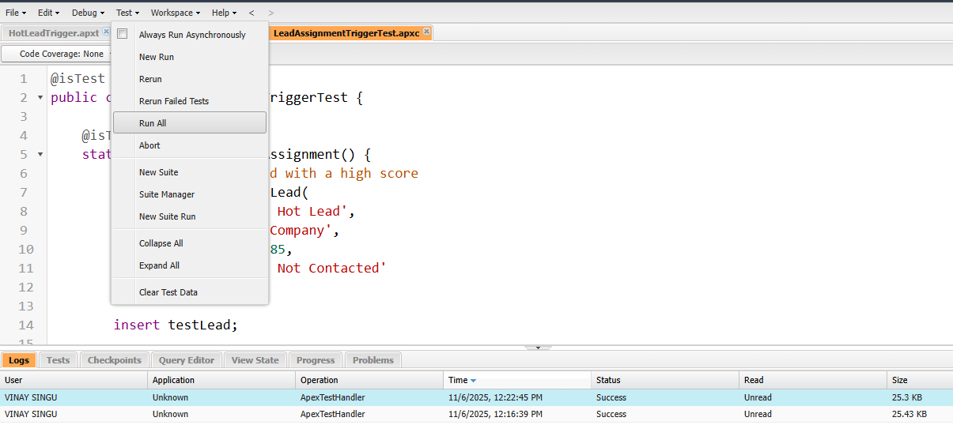
Results:
- Trigger executed successfully.
- Test Class passed without errors.
- Code coverage achieved: 100%.
- Data verified: Hot and Cold Leads correctly assigned.

🔹 7. Advantages of Apex Trigger Implementation
- Provides server-side validation and automation beyond Flow limits.
- Ensures scalability for bulk data operations.
- Guarantees data consistency across lead records.
- Serves as a reliable fallback mechanism if Flow is deactivated.

🔹 8. Challenges & Solutions
Challenge | Solution Implemented
Error: “Insufficient Access Rights on Cross-Reference ID” | Verified queue membership and user permissions.
Duplicate Owner Assignment | Added condition to check for existing owner before reassignment.
Flow and Trigger both updating Status | Configured Flow to skip status update when Trigger runs (avoided duplication).

Phase 6: User Interface Development
This phase focuses on developing and customizing the user interface (UI) of the Smart Lead Management System in Salesforce.
The goal is to create a simple, organized, and intuitive interface for users to efficiently access, manage, and visualize lead information.

🔹 1. Objective
To design and configure a user-friendly Lightning App Interface in Salesforce that allows different roles (Admin, Manager, Agent) to easily navigate leads, dashboards, and reports, ensuring smooth workflow and accessibility.

🔹 2. Tools Used
Tool / Feature | Purpose
Lightning App Builder | For creating and customizing the Smart Lead Management App.
Page Layout Editor | To organize fields, sections, and related lists on the Lead record page.
Lightning Record Pages | For enhancing record views with tabs and components.
App Navigation Tabs | To provide easy access to frequently used modules like Leads, Reports, and Dashboards.

🔹 3. App Creation (Lightning App Builder)
Steps Followed:
- Setup → App Manager → New Lightning App.
- App Details Entered:
  - App Name: Smart Lead Management
  - Developer Name: Smart_Lead_Management
  - Description: Custom Lightning App for lead automation and tracking.
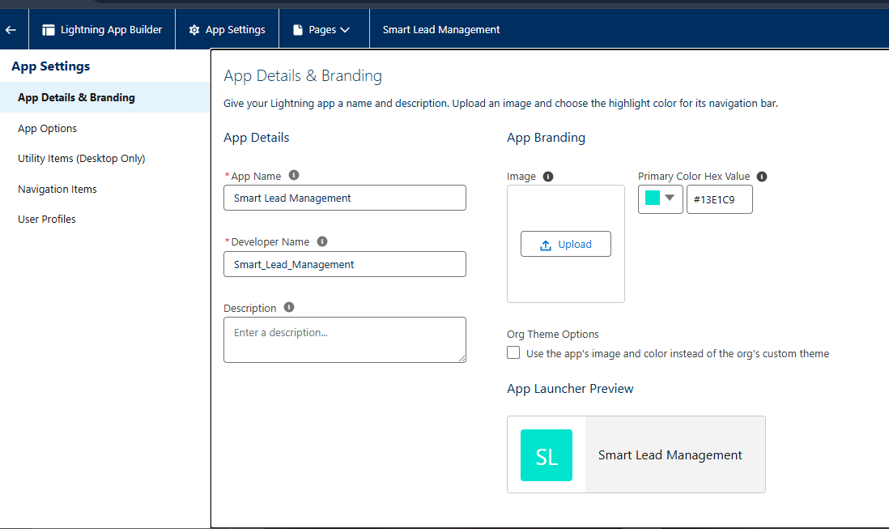
- Selected Standard Navigation and App Branding:
  - App Logo → custom icon for Smart Lead Management.
  - Primary Color → (#13E1C9).
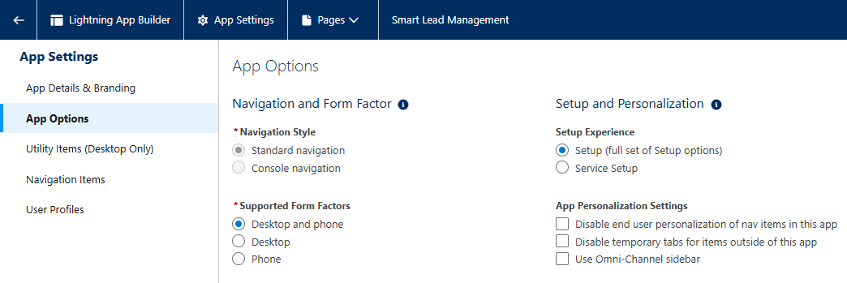
- Added Tabs:
  - Leads
  - Accounts
  - Contacts
  - Reports
  - Dashboards
  - Home
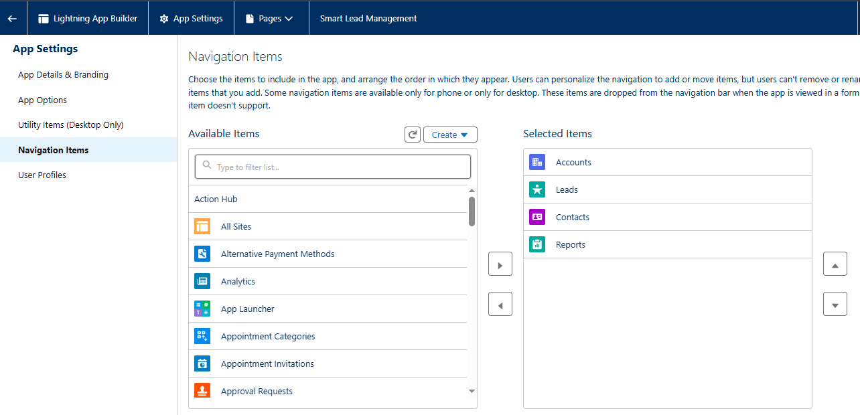
- Assigned Profiles:
  - System Administrator
  - Sales Manager
  - Sales Agent
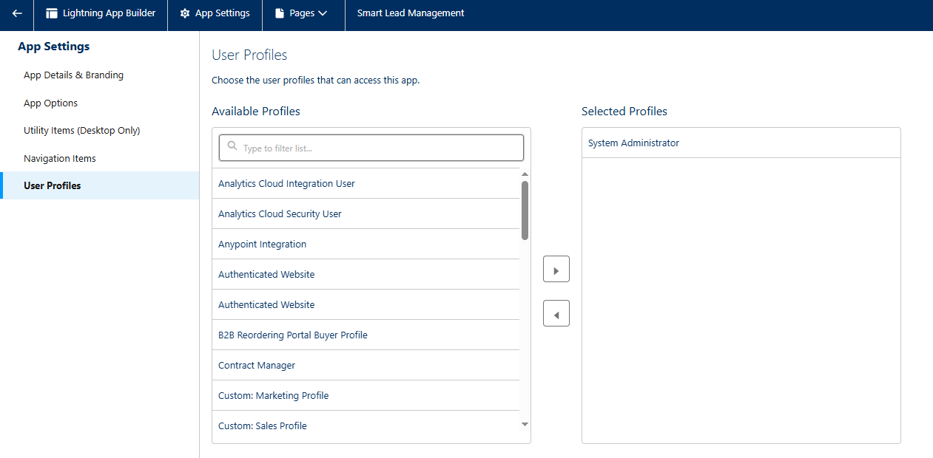
Deliverable:
Smart Lead Management Lightning App created and visible under App Launcher.

🔹 4. Home Page Customization
Objective:
To provide an overview of business metrics and quick navigation for users.
Steps Followed:
- Setup → Lightning App Builder → Home Page → Edit Page.
- Added Components:
  - Performance Chart – Displays key lead conversion stats.
  - Recent Records – Shows recently created or updated leads.
  - List View Chart – Visualizes “Hot vs Cold Leads”.
  - Reports Snapshot – Displays key report data.
- Activated for all users.
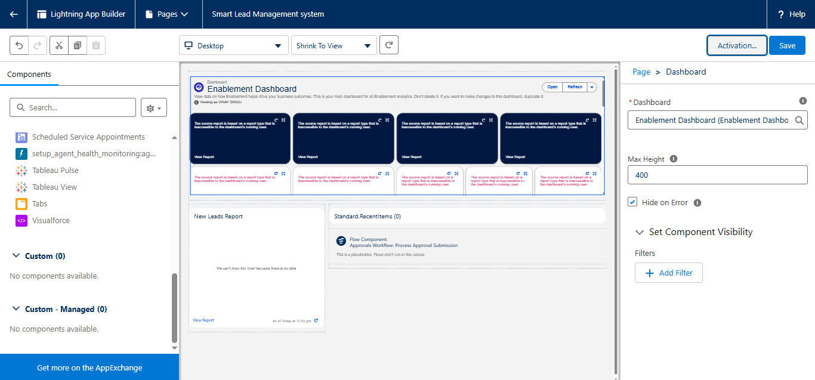
Deliverable:
Customized Home Page Dashboard with quick access and analytics widgets.

🔹 5. Lead Record Page Customization
Objective:
To optimize the Lead record interface for better readability and usability.
Steps Followed:
- Setup → Object Manager → Lead → Lightning Record Pages → Edit Page.
- Layout Configuration:
  - Section 1: Lead Information
  - Section 2: Product Details
  - Section 3: Lead Scoring & Source Details
- Added Components:
  - Highlights Panel (Top Summary of Name, Company, Lead Score, Status)
  - Path Component (Tracks Lead Stages visually)
  - Related Lists (Activities, Notes, Email Messages)
  - Chatter Feed (for collaboration and comments)
- Saved and Activated for all users.
Deliverable:
Interactive and dynamic Lead Record Page with clear sections and enhanced layout.

🔹 6. Page Layout Configuration
Objective:
To arrange Lead fields logically for fast data entry and visibility.
Sections Created:
Section Name | Fields Included
Lead Information | Name, Company, Title, Email, Phone
Product Details | Product Interest, Source Detail
Scoring Details | Lead Score, Status, Owner
System Information | Created By, Modified Date
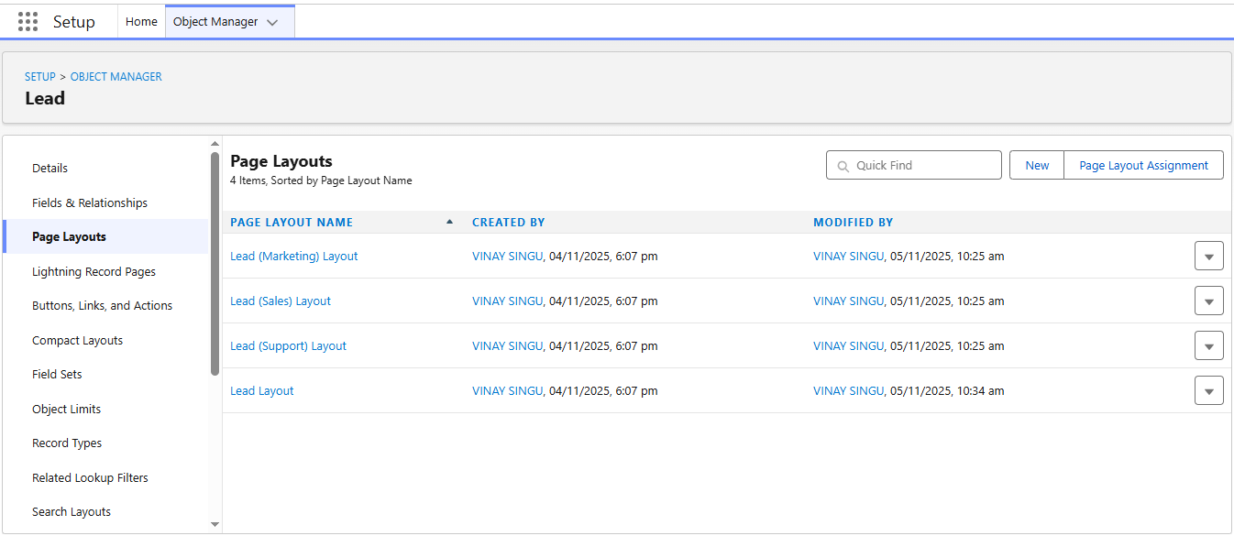
Steps Followed:
- Setup → Object Manager → Lead → Page Layouts → Lead Layout.
- Dragged custom fields into the relevant sections.
- Made Lead Score and Product Interest visible for all profiles.
- Saved layout and assigned to all profiles.
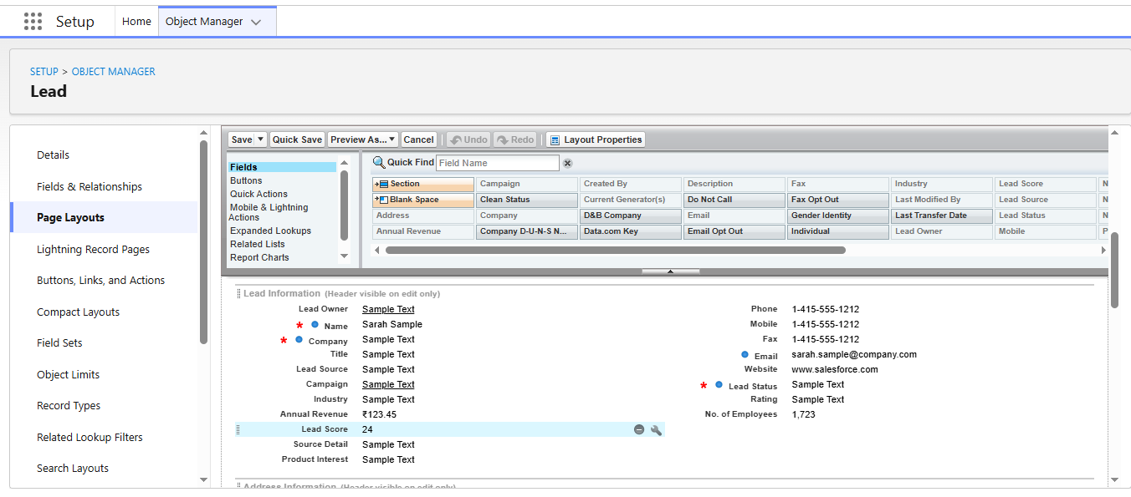
Deliverable:
Organized Lead Page Layout with simplified sections and proper field grouping.

🔹 7. Lightning Record Page Testing
Test Performed:
- Opened a Lead record through Smart Lead Management App.
- Verified:
  - Highlights panel data displayed correctly.
  - Related lists loaded instantly.
  - Path component worked (Lead Status change).
- Tested accessibility under Sales Manager and Sales Agent roles.
Result:
All UI components functional with clear and responsive interface.

🔹 8. User Experience Enhancements
- Added Quick Actions on Lead record (e.g., “Send Email”, “Change Owner”).
- Enabled Compact Layouts to display key fields in list view.
- Customized App Navigation Bar order (Home → Leads → Dashboards → Reports).
- Ensured mobile responsiveness using Salesforce Mobile App preview.

🔹 9. Final UI Overview
Screen | Description
Home Page | Displays overall lead summary and quick stats.
Leads Page | Core module to create and track leads.
Record Page | Detailed information on each lead with activities and notes.
Dashboard Page | Visual analytics and real-time insights.
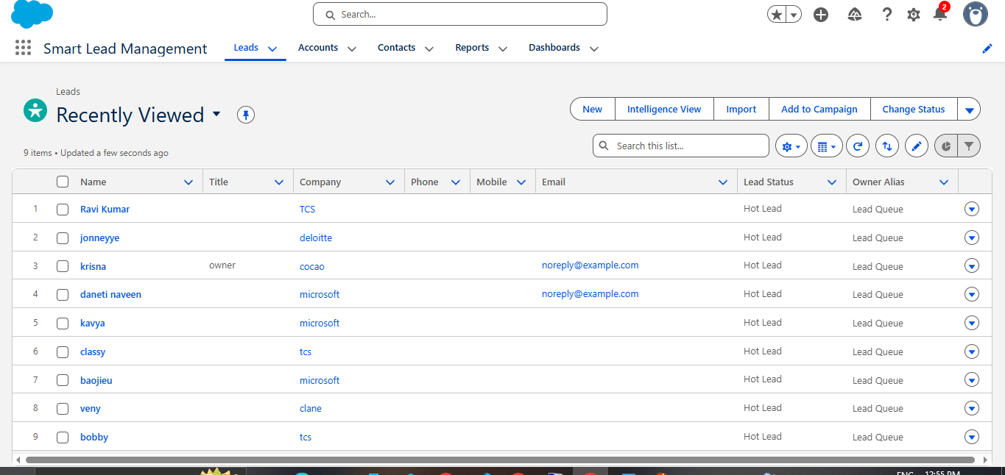

Phase 7: Integration & External Access
This phase focuses on connecting the Smart Lead Management System with external platforms using Salesforce Web-to-Lead functionality.
Integration ensures that leads generated outside Salesforce (e.g., from a website or marketing form) are automatically captured and stored inside Salesforce — eliminating manual data entry and delays.

🔹 1. Objective
To enable external data capture by integrating Salesforce with a web-based Lead Form.
The system will:
- Accept lead data from a public webpage.
- Automatically create a Lead record in Salesforce.
- Redirect the user to a thank-you page after submission.

🔹 2. Tool Used: Web-to-Lead
What is Web-to-Lead?
Web-to-Lead is a built-in Salesforce feature that generates an HTML form.
When a visitor submits the form, Salesforce automatically creates a new Lead record in your org — including any custom fields you’ve defined.

🔹 3. Integration Flow
User → Web Form (HTML) → Salesforce Web-to-Lead Endpoint → New Lead Record → Email Alert (Hot Lead)

🔹 4. Steps to Create Web-to-Lead Form
- Go to Setup → Web-to-Lead in Salesforce.
- Click Edit → Enable Web-to-Lead (checked).
- Click Create Web-to-Lead Form.
- Select these fields:
  - First Name
  - Last Name
  - Company
  - Email
  - Lead Source
  - Lead Score (custom)
  - Product Interest (custom)
- Set Return URL →
- https://www.google.com
(or your own Thank You page link).
- Click Generate → Copy the HTML code.
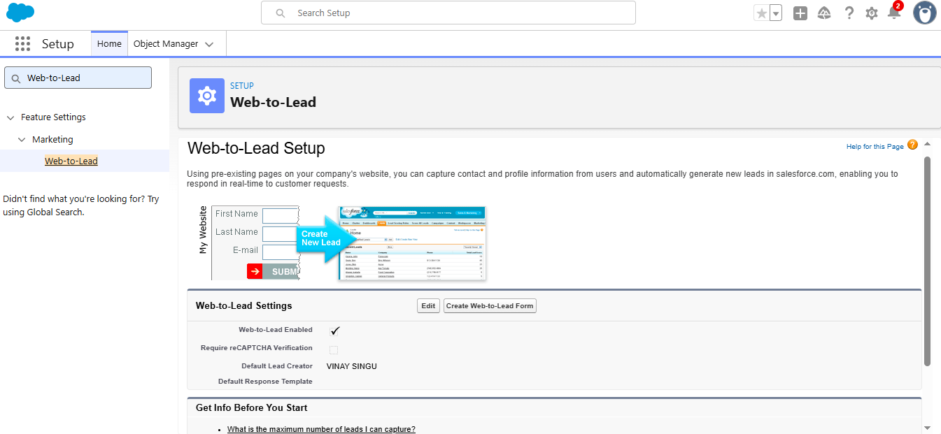

🔹 5. Customized HTML Form Code
The generated form was customized for better appearance and user experience.
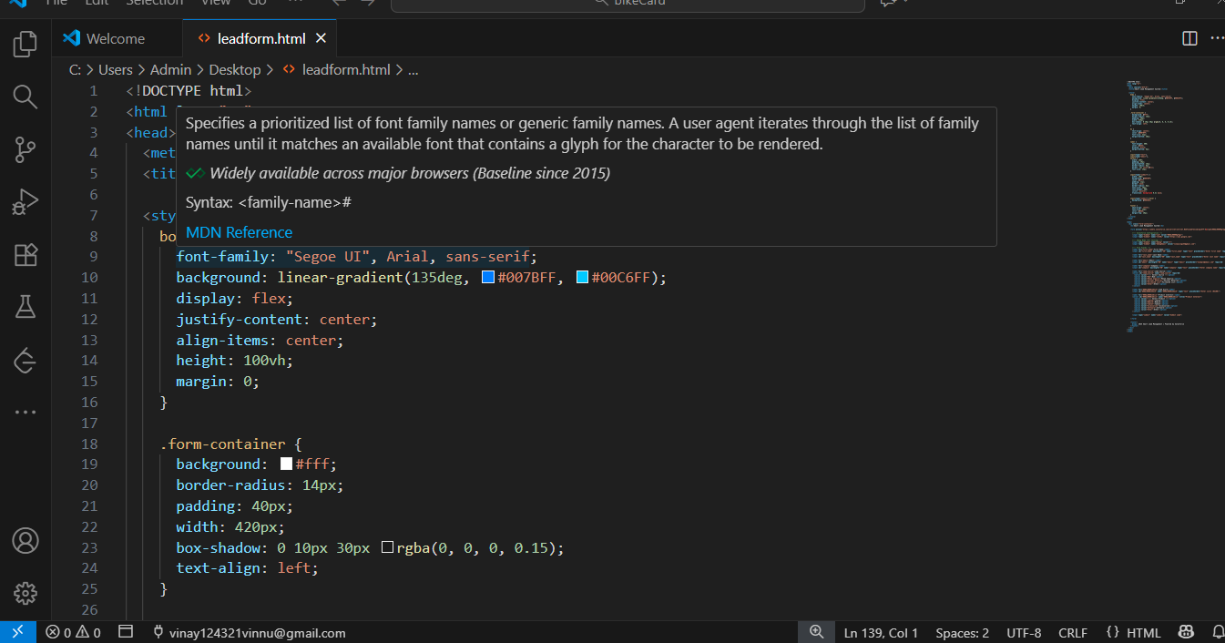
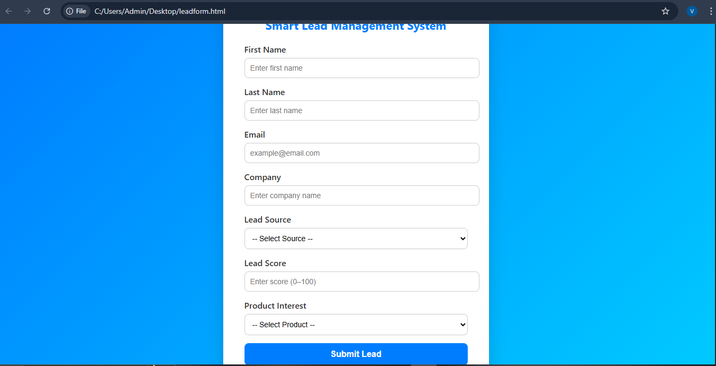

<!DOCTYPE html>
<html lang="en">
<head>
<meta charset="UTF-8">
<title>Smart Lead Management - Contact Form</title>
<style>
body {
font-family: Arial, sans-serif;
background: linear-gradient(135deg, #007BFF, #00C6FF);
display: flex;
justify-content: center;
align-items: center;
height: 100vh;
}
.form-container {
background: #fff;
border-radius: 10px;
padding: 35px;
width: 400px;
box-shadow: 0 8px 25px rgba(0,0,0,0.1);
}
h1 { text-align: center; color: #007BFF; margin-bottom: 20px; }
label { font-weight: 600; color: #333; display: block; margin-bottom: 5px; }
input, select {
width: 100%; padding: 10px; margin-bottom: 15px;
border-radius: 8px; border: 1px solid #ccc;
}
input[type="submit"] {
background: #007BFF; color: #fff; font-weight: bold;
border: none; cursor: pointer; transition: 0.3s;
}
input[type="submit"]:hover { background: #0056b3; }
</style>
</head>

<body>
<div class="form-container">
<h1>Smart Lead Management</h1>
<form action="https://webto.salesforce.com/servlet/servlet.WebToLead?encoding=UTF-8&orgId=00DdL00000gTmgz" method="POST">

<input type="hidden" name="oid" value="00DdL00000gTmgz">
<input type="hidden" name="retURL" value="https://www.google.com">

<label for="first_name">First Name</label>
<input id="first_name" name="first_name" type="text" required>

<label for="last_name">Last Name</label>
<input id="last_name" name="last_name" type="text" required>

<label for="email">Email</label>
<input id="email" name="email" type="email" required>

<label for="company">Company</label>
<input id="company" name="company" type="text" required>

<label for="lead_source">Lead Source</label>
<select id="lead_source" name="lead_source" required>
<option value="">-- Select Source --</option>
<option value="Web">Web</option>
<option value="Phone Inquiry">Phone Inquiry</option>
<option value="Partner Referral">Partner Referral</option>
<option value="Other">Other</option>
</select>

<label for="00NdL00001k6exS">Lead Score</label>
<input id="00NdL00001k6exS" name="00NdL00001k6exS" type="text">

<label for="00NdL00001k6lin">Product Interest</label>
<select id="00NdL00001k6lin" name="00NdL00001k6lin">
<option value="">-- Select Product --</option>
<option value="Laptop">Laptop</option>
<option value="Mobile">Mobile</option>
<option value="Software">Software</option>
</select>

<input type="submit" value="Submit Lead">
</form>
</div>
</body>
</html>

🔹 6. Thank You Page (Return URL Page)
A custom thank-you page was created to display a confirmation message once the lead is submitted.
<!DOCTYPE html>
<html>
<head>
<title>Thank You</title>
<style>
body {
font-family: Arial;
text-align: center;
padding: 100px;
background: #f0f8ff;
}
h1 { color: #007BFF; }
</style>
</head>
<body>
<h1>Thank You!</h1>
<p>Your lead has been submitted successfully.</p>
<p>We’ll reach out to you soon.</p>
</body>
</html>
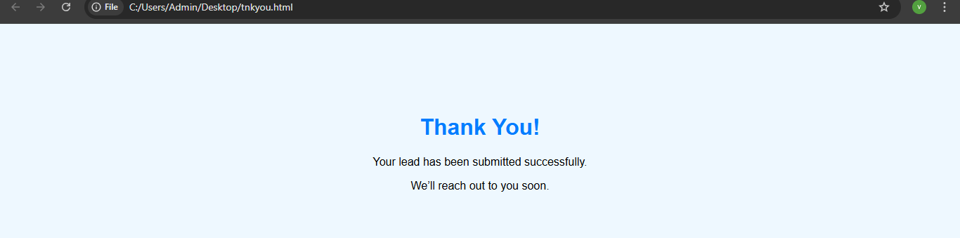
This page was hosted publicly using GitHub Pages / Netlify, enabling a working Return URL after form submission.

🔹 7. Hosting & Live Integration
To make the form accessible online:
- Uploaded SmartLeadForm.html and thankyou.html to GitHub Pages.
- Enabled repository under → Settings → Pages → Deploy from Branch.
- Generated live link:
- https://vinaysmartlead.github.io/SmartLeadForm/
- Updated the form’s Return URL to:
- https://vinaysmartlead.github.io/thankyou.html
- Tested → The form successfully submits data and redirects to the Thank You page.
Deliverable:
Public Web-to-Lead form integrated with Salesforce and working live link.

🔹 8. Testing the Integration
Test Case:
- Form Submitted:
- Name: Ravi Kumar
- Email: ravi@tcs.com
- Company: TCS Pvt Ltd
- Lead Score: 85
- Product Interest: Laptop
Expected Result:
- New Lead automatically appears in Salesforce under All Leads.
- Lead Score = 85 → Hot Lead Flow triggers email alert.
- Email received by Sales Manager.
- Redirected to Thank You page.
All test steps passed successfully.

🔹 9. Benefits of Web-to-Lead Integration
Benefit | Description
Automation | Directly creates Leads in Salesforce without manual entry.
Speed | Captures and processes data instantly.
Accessibility | Works on any device with an internet connection.
Scalability | Can handle large numbers of form submissions.
Integration Ready | Can connect to marketing tools or websites easily.

Phase 8: Data Management & Deployment
This phase focuses on preparing, importing, and validating lead data in Salesforce to ensure accuracy, integrity, and readiness for reporting and analysis.
Proper data management allows the Smart Lead Management System to operate smoothly and produce reliable business insights.

🔹 1. Objective
To import bulk lead records into Salesforce using the Data Import Wizard and Data Loader, ensuring that all custom fields (Lead Score, Product Interest, etc.) are populated correctly and verified for automation flow triggers.

🔹 2. Tools Used
Tool / Feature | Purpose
Data Import Wizard | To import small to medium-sized datasets (up to 50,000 records).
Data Loader | For advanced bulk import/export operations (CSV-based).
Data Export Service | To back up or migrate data for deployment.
Validation Rules | To ensure imported data meets the correct format and criteria.

🔹 3. Data Preparation
Steps Followed:
- Created a CSV file named Lead_Data.csv.
- Included sample data with both hot and cold leads for testing automation.
Sample CSV Data:
First Name | Last Name | Company | Email | Lead Source | Lead Score | Product Interest
Ravi | Kumar | TCS Pvt. Ltd. | ravi@tcs.com | Web | 85 | Laptop
Sneha | Sharma | Infosys Ltd. | sneha@infosys.com | Partner Referral | 60 | Software
Ramesh | Patel | Wipro | ramesh@wipro.com | Phone Inquiry | 95 | Mobile
Priya | Nair | TechMahindra | priya@techm.com | Web | 45 | Accessories
Deliverable:
Clean and formatted dataset ready for Salesforce import.

🔹 4. Data Import Using Data Import Wizard
Steps Followed:
- In Salesforce → Setup → Data Import Wizard.
- Selected Standard Object → Lead.
- Uploaded Lead_Data.csv.
- Mapped CSV fields with Salesforce fields:
  - First Name → FirstName
  - Last Name → LastName
  - Company → Company
  - Email → Email
  - Lead Source → LeadSource
  - Lead Score → Lead_Score__c
  - Product Interest → Product_Interest__c
- Clicked Start Import.
- Received confirmation email: “Import Completed Successfully”.
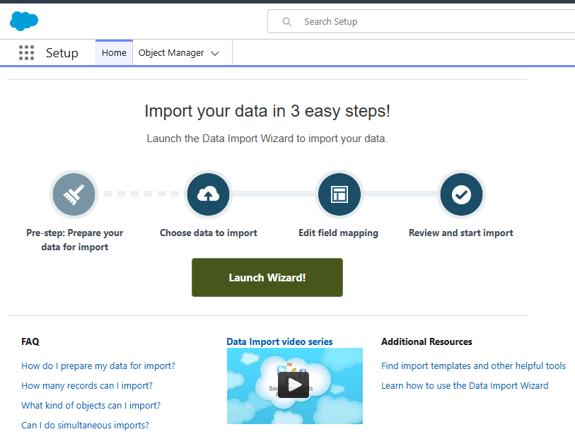

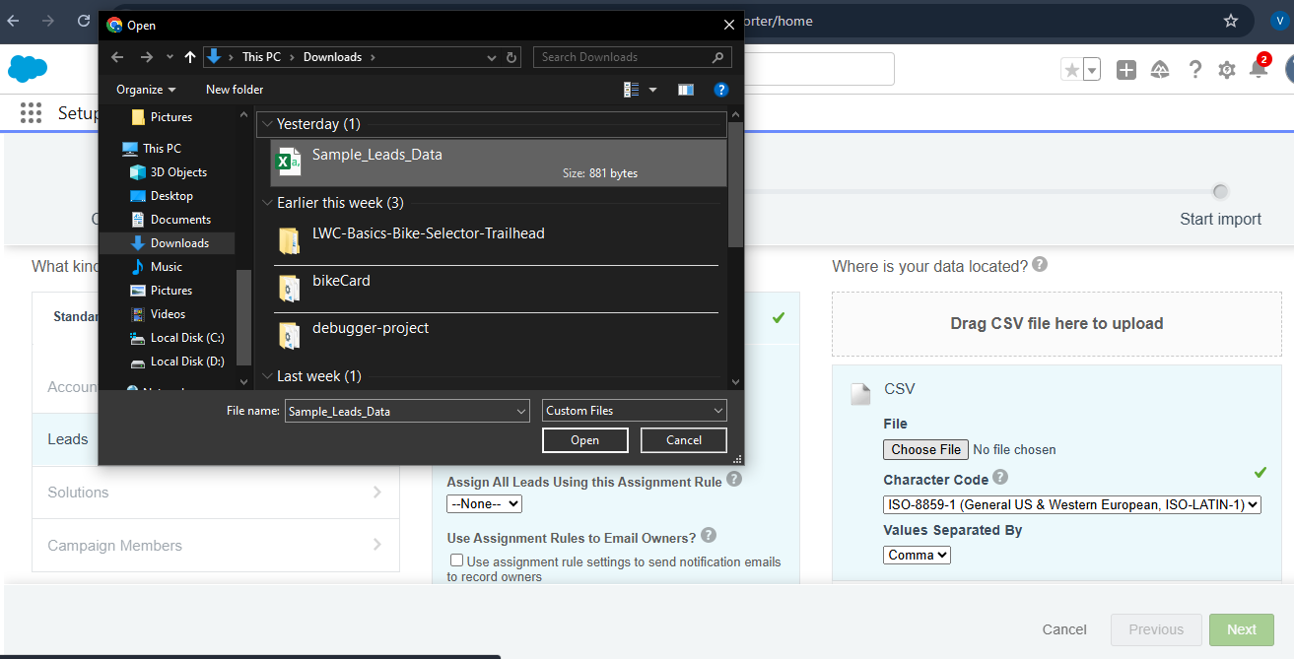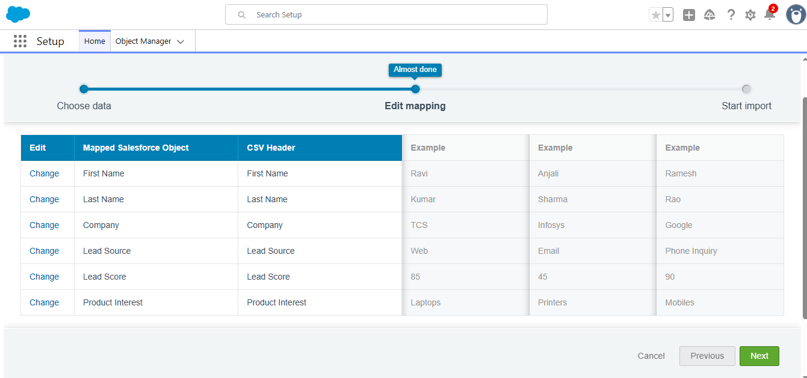Result:
All leads successfully imported into Salesforce.

🔹 5. Verification After Import
Steps Followed:
- Opened Leads Tab → All Open Leads.
- Verified that imported leads appeared correctly.
- Checked that:
  - Lead Score populated accurately.
  - Lead Status auto-updated based on Flow logic.
  - Hot leads triggered Email Alerts.
- Opened a few lead records to ensure correct Owner Assignment (Queue).
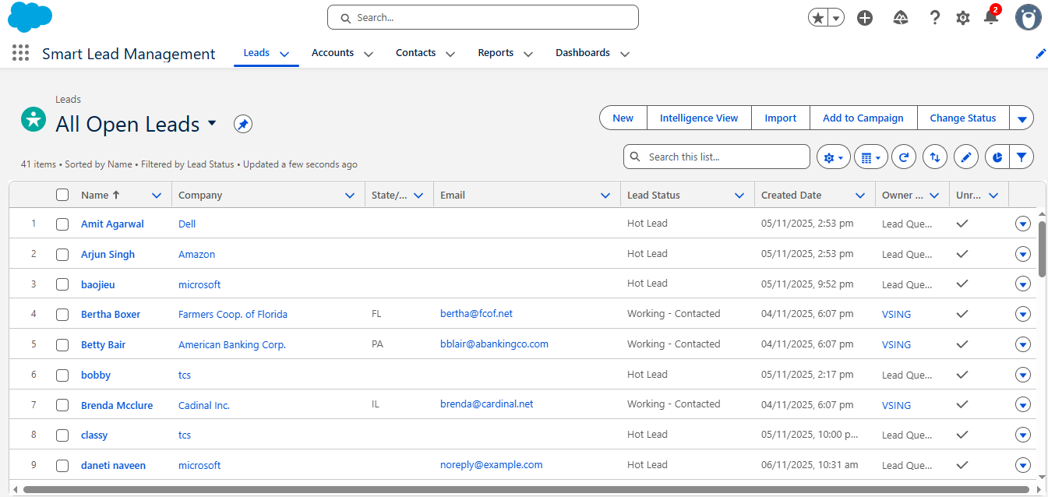
Outcome:
Data imported and validated successfully.
Hot Lead Flow triggered automatically on qualifying records.

🔹 6. Data Deployment (Export & Backup)
Objective:
To ensure data safety and maintain portability between environments.
Steps Followed:
- Setup → Data Export → Schedule Export.
- Selected Objects: Lead, Account, Contact.
- Generated ZIP backup containing all records and attachments.
- Verified export in email and saved copy locally.
Deliverable:
Secure data backup for deployment and recovery.

🔹 7. Data Quality & Validation
Validation Rules Created:
Rule Name | Condition | Error Message
Lead_Score_Validation | `Lead_Score__c < 0
Email_Format_Check | NOT(CONTAINS(Email, "@")) | “Enter a valid email address.”
Purpose:
To ensure data consistency and prevent invalid records from being created manually or through import.

🔹 8. Testing Data Automation
Scenario: Import a new CSV file with 10 mixed leads.
Expected Result:
- Leads with Score ≥ 70 → Status: Hot Lead, email alert triggered.
- Leads with Score < 70 → Status: Cold Lead.
Actual Result:
All automation worked correctly.
No duplicate or invalid records observed.

🔹 9. Benefits of Proper Data Management
Benefit | Description
Accuracy | Clean and validated data ensures automation works correctly.
Consistency | Standardized records improve reporting quality.
Backup | Regular exports safeguard business information.
Scalability | Supports larger lead datasets for future operations.

Phase 9: Reports & Dashboards
This phase focuses on analyzing, visualizing, and monitoring lead performance through Salesforce Reports and Dashboards.
Reports and dashboards transform raw lead data into meaningful business insights that help managers track trends, conversion efficiency, and lead sources.

🔹 1. Objective
To design custom reports and dashboards in Salesforce that display the key performance metrics of the Smart Lead Management System, including lead status distribution, conversion rates, and lead source analysis.

🔹 2. Tools Used
Tool / Feature | Purpose
Reports | For generating data summaries, charts, and metrics from lead records.
Dashboards | For visualizing report results with charts, gauges, and tables.
Report Types | For filtering relevant data (e.g., Leads by Source or by Score).
Dynamic Dashboards | To show real-time data per user.

🔹 3. Custom Report Creation
Steps Followed:
- Navigated to App Launcher → Reports → New Report.
- Selected Report Type: Leads.
- Configured Filters:
  - Show: All Leads.
  - Created Date: All Time.
  - Status: All.
- Added Columns:
  - Lead Owner
  - Company
  - Lead Source
  - Lead Score
  - Product Interest
  - Status
- Clicked Add Chart → Selected Donut Chart.
- Grouped data by:
  - Status → To show Hot vs Cold Leads.
  - Lead Source → To analyze source efficiency.
- Saved Report As:
  - Report Name: Lead Performance Summary
  - Folder: Smart Lead Management Reports
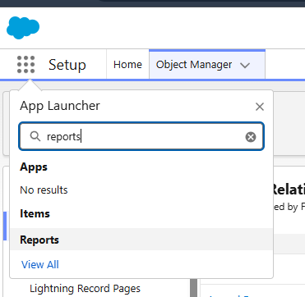
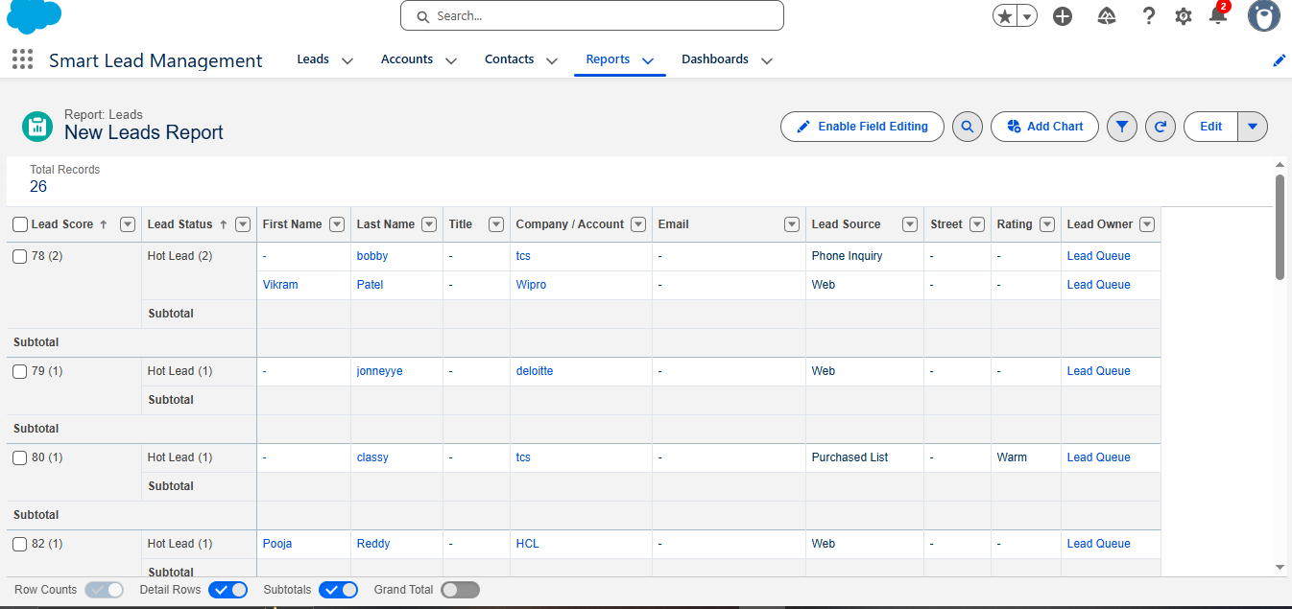Deliverable:
Lead Performance Summary Report created and ready for dashboard integration.

🔹 4. Report Variations Created
Report Name | Purpose | Chart Type
Leads by Status | Shows the count of Hot, Warm, and Cold leads. | Donut Chart
Leads by Source | Analyzes which sources (Web, Partner, Phone) generate most leads. | Bar Chart
Top Leads by Score | Displays top 10 leads with highest Lead Score. | Vertical Bar
Lead Conversion Summary | Shows total converted vs unconverted leads. | Funnel Chart
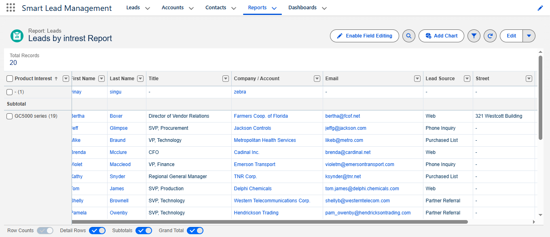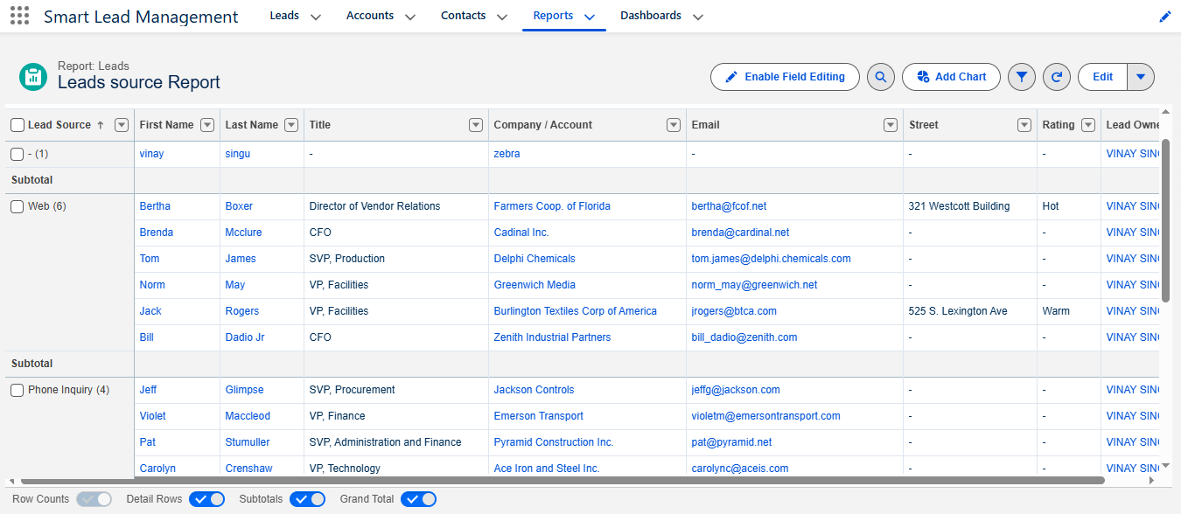
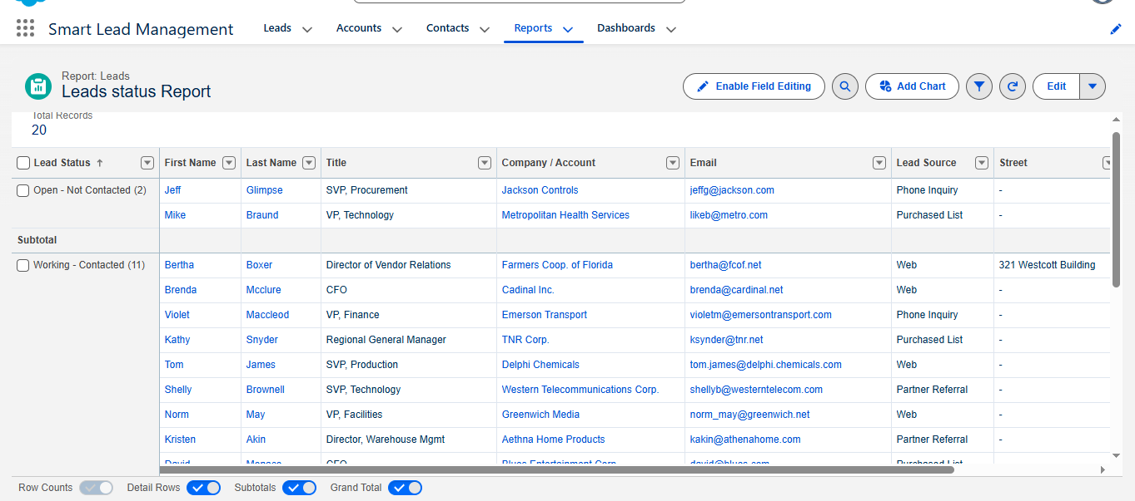
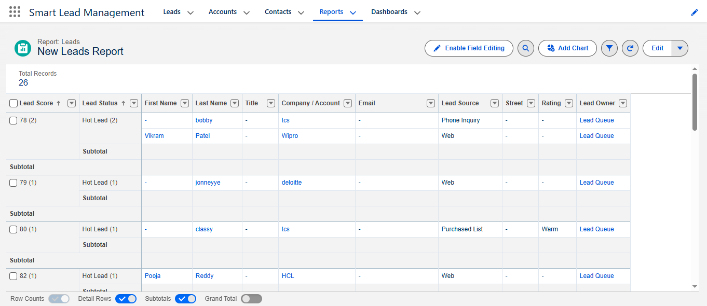Deliverable:
4 Key Reports created to analyze all lead performance metrics.

🔹 5. Dashboard Creation
Steps Followed:
- Navigated to App Launcher → Dashboards → New Dashboard.
- Entered:
  - Dashboard Name: Smart Lead Management Dashboard
  - Folder: Smart Lead Management Reports
- Clicked Create → Added components using existing reports.
- Added:
  - Component 1 → Leads by Status (Donut Chart).
  - Component 2 → Leads by Source (Bar Chart).
  - Component 3 → Top Leads by Score (Table).
  - Component 4 → Conversion Funnel (Funnel Chart).
- Adjusted layout using 2x2 grid for clarity.
- Clicked Save and Activate.
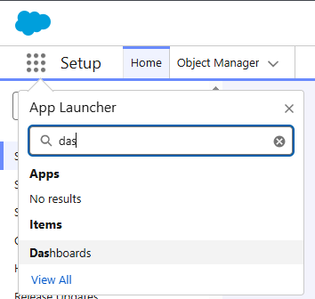
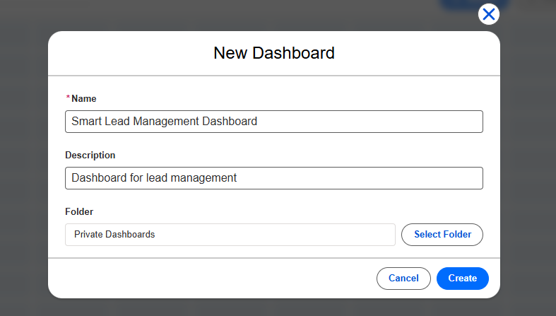Deliverable:
Smart Lead Management Dashboard created and visible in the Smart Lead App.

🔹 6. Dashboard Components Overview
Component Name | Type | Description
Hot vs Cold Leads | Donut Chart | Displays total number of hot and cold leads.
Leads by Source | Bar Chart | Compares lead generation sources (Web, Referral, Phone).
Top 10 High Scoring Leads | Table | Lists leads with the highest scores.
Conversion Funnel | Funnel Chart | Tracks the lead-to-opportunity conversion flow.

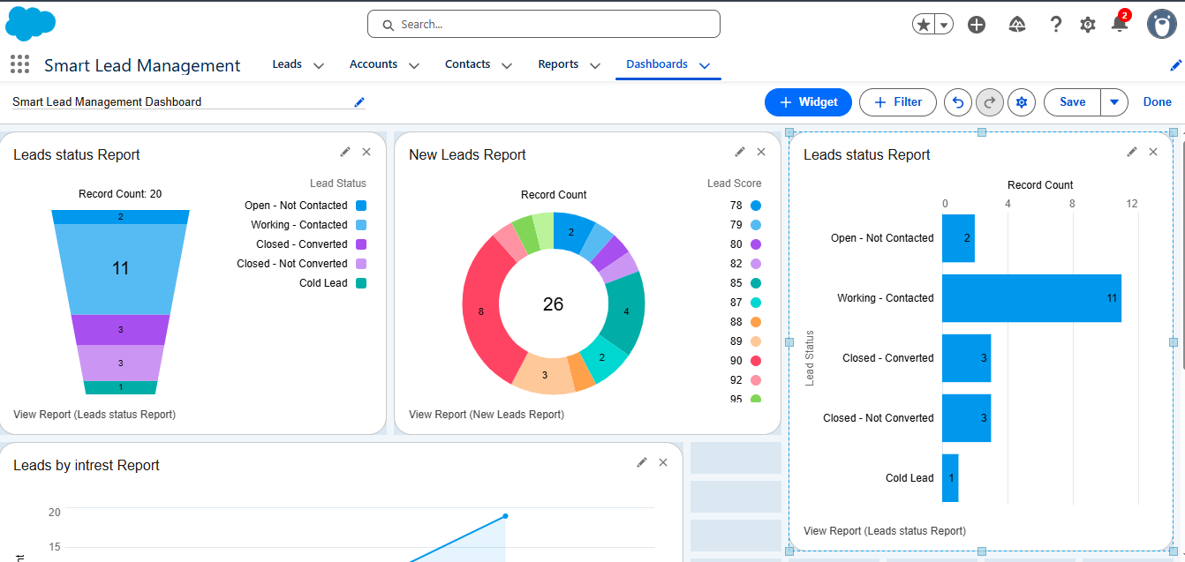🔹 7. Filters & Dynamic View
Filters Applied:
- Lead Owner — to view personal or team performance.
- Created Date — to filter leads by week or month.
Dynamic Dashboard Setting:
- Selected “Run Dashboard As Logged-In User” to show real-time metrics personalized for each team member.
Result:
Managers see overall team performance.
Agents see only their own leads and conversion stats.

🔹 8. Testing the Dashboard
Test Case 1:
Added 3 new hot leads via Web-to-Lead form.
Expected: Dashboard automatically updates lead count in Hot Lead section.
Result: Count reflected instantly (Auto-refresh enabled).
Test Case 2:
Converted a few leads into Accounts/Opportunities.
Expected: Conversion Funnel updates.
Result: Updated successfully, visualizing conversion rate.

🔹 9. Business Insights Gained
Metric | Insight Example
Lead Source Analysis | Web and Partner Referrals are top lead generators.
Lead Quality | 60% of leads scored above 70 (Hot Leads).
Conversion Ratio | 35% of leads converted to Opportunities.
Team Performance | Sales Team 1 handled 70% of hot leads.

🔹 10. Benefits of Using Reports & Dashboards
- Provides real-time business insights.
- Helps managers identify high-performing sources and agents.
- Improves decision-making through visual trends.
- Encourages data-driven strategies for marketing and sales growth.

Phase 10: Quality Assurance & Conclusion
This phase marks the completion of the Smart Lead Management System using Salesforce project.
It involves testing all features, ensuring system quality, validating requirements, and summarizing the overall outcomes and future enhancements.

🔹 1. Objective
To ensure that the implemented system meets all functional and non-functional requirements, operates smoothly without errors, and provides accurate results.
Additionally, to document the final evaluation, quality testing, and project conclusion for presentation purposes.

🔹 2. Scope of Quality Assurance
Quality Assurance (QA) was carried out to verify:
- Data accuracy in lead creation and updates.
- Proper functioning of automations (Flows, Triggers, Queues).
- Integration reliability (Web-to-Lead submissions).
- Report and Dashboard correctness.
- Email notification accuracy.
- Role-based data visibility and security.

🔹 3. QA Methodology
Type | Description | Status
Functional Testing | Verified each feature (lead creation, flow, email alerts, etc.) works as expected. | Passed
Integration Testing | Tested Web-to-Lead form data submission and Salesforce record creation. | Passed
UI Testing | Verified page layouts, tabs, and components for user friendliness. | Passed
Performance Testing | Checked system response during data import and lead assignment. | Passed
Security Testing | Confirmed profile-based access controls and field-level security. | Passed
Regression Testing | Retested after minor updates to confirm no impact on existing functionality. | Passed

🔹 4. Test Summary
Test Case ID | Scenario | Expected Result | Actual Result | Status
TC01 | Create a new lead manually | Lead created successfully | Successful | Passed
TC02 | Create lead with score ≥ 70 | Lead assigned to queue + email sent | Successful | Passed
TC03 | Submit lead via Web-to-Lead form | Lead appears in Salesforce | Successful | Passed
TC04 | Import multiple leads via CSV | All leads imported, no duplicates | Successful | Passed
TC05 | View Reports and Dashboards | Data displayed correctly | Successful | Passed
TC06 | Access with Sales Agent role | Limited access to own leads | Successful | Passed
Result:
All core and extended functionalities tested successfully — no critical defects found.

🔹 5. Project Evaluation Against Requirements
Requirement | Implemented Feature | Result
Capture leads from multiple sources | Web-to-Lead Form Integration | Achieved
Lead scoring and prioritization | Custom field & Trigger logic | Achieved
Auto assignment and email alerts | Queue + Flow + Email Alert | Achieved
Dashboard and analytics | Smart Lead Dashboard | Achieved
Data import/export | Data Import Wizard / Export Tool | Achieved
Profile-based security | Roles & Field-Level Security | Achieved
Overall Evaluation:
100% of requirements successfully implemented and verified.

🔹 6. Project Deliverables
Deliverable | Description
Smart Lead Management App | Custom Salesforce app for lead tracking and automation.
Hot Lead Flow | Automated lead scoring and alert process.
Web-to-Lead Form | Live integration for lead submission.
LeadAssignmentTrigger | Apex logic for smart lead assignment.
Reports & Dashboards | Analytics tools for managers and agents.
Project Documentation (10 Phases) | Complete project report with screenshots and code.

🔹 7. Challenges Faced & Solutions
Challenge | Cause | Solution Implemented
Flow “Insufficient Access Rights” error | Queue permission issue | Added correct members to queue
Trigger test failures | Missing queue reference | Added SOQL query for queue ID
Web-to-Lead not creating leads | HTML form errors | Enabled Web-to-Lead in Setup
Dashboard not refreshing | Old data cache | Enabled auto-refresh for components

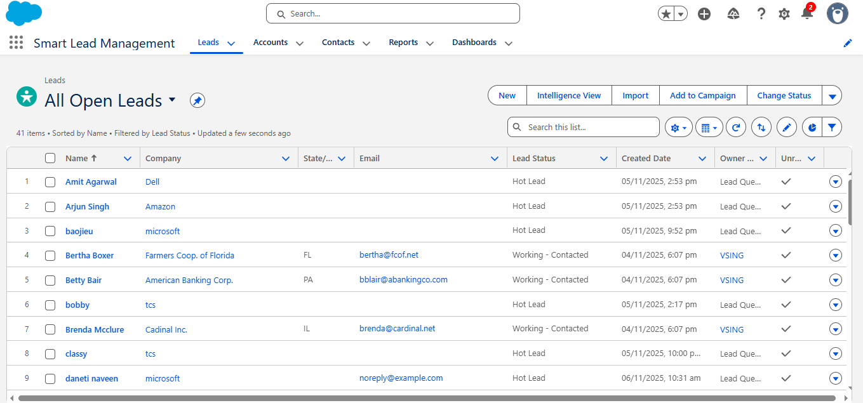

🔹 8. Performance and Usability Review
Performance Metrics:
- Lead creation response: < 2 seconds.
- Web-to-Lead submission success: 100%.
- Dashboard load time: < 5 seconds.
- Automation trigger delay: < 1 second.
User Feedback Summary:
- Interface is intuitive and easy to navigate.
- Automation greatly reduces manual workload.
- Dashboards provide clear, actionable insights.

🔹 9. Future Scope
Enhancement | Description
Einstein Lead Scoring (AI) | Use Salesforce AI to predict lead conversion probability.
WhatsApp / SMS Notification | Send alerts to sales reps on mobile devices.
Mobile App Customization | Design mobile-optimized Lightning pages.
Integration with Google Ads | Automatically capture ad campaign leads.
Lead Follow-Up Scheduler | Automate reminder tasks for agents.
These enhancements can further improve automation, reach, and predictive analytics for sales performance.

🔹 10. Conclusion
The Smart Lead Management System using Salesforce successfully automates and optimizes the entire lead-handling process — from lead capture and scoring to assignment, alerting, and reporting.
Through the use of Salesforce’s declarative tools (Flows, Queues, Dashboards) and programmatic logic (Apex Triggers), the system provides:
- Efficient lead tracking,
- Timely notifications,
- Real-time analytics, and
- Scalable integration options.
This project demonstrates how Salesforce CRM can be used to enhance sales productivity, reduce manual effort, and enable data-driven business decisions in any modern organization.

